DOCUMENTATION OF VISUAL STUDIO

Visual Studio Download Site Link

<https://visualstudio.microsoft.com/downloads/>

* Click the above link to reach the visual studio platform
* The below image shown the three different options for download visual studio
* Choose community edition in the below image for download visual studio

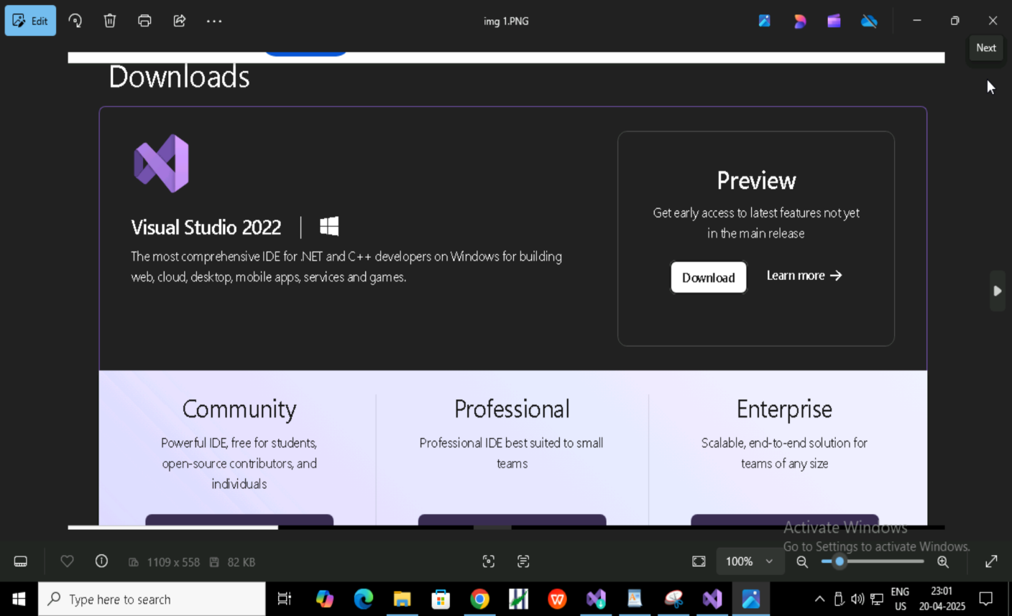

* Go to windows and search (visual studio installer)and open the page

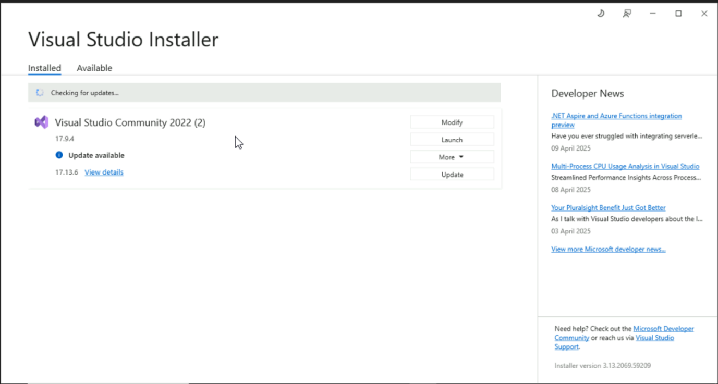

* The above page(visual studio installer)is shown many options
* Click (modify)option

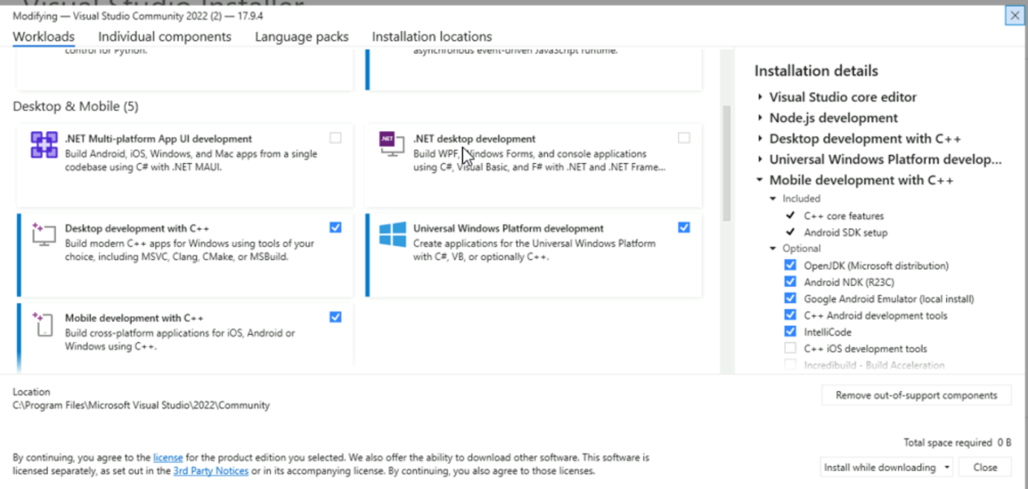

* It shown the many options in (workloads)
* Scroll down the page and there is one option (Desktop development with C++) click the checkbox

* In same page it shown many option right side
* Select all the options shown in the above image

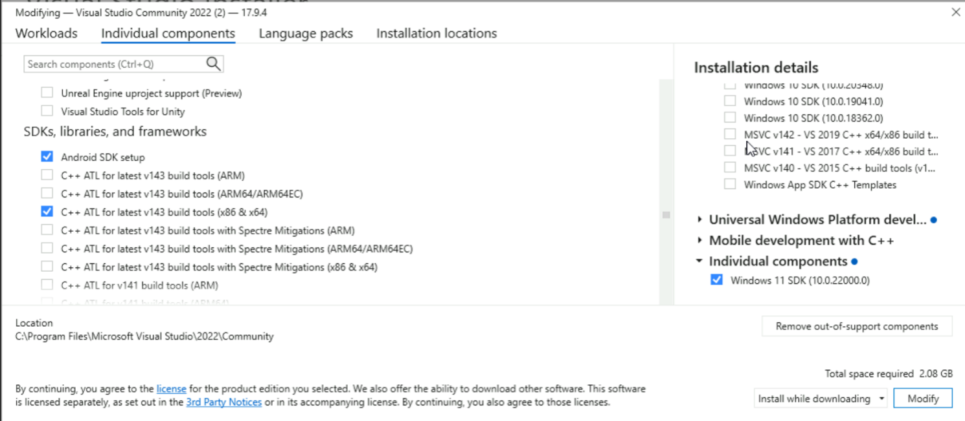

* Go to invidual components and search for:

1. C++ CMake tools for windows
2. MSVC V143-VS 2022 C++ x64/x86 build
3. Tools(latest)
4. MSVC V140-VS 2015 C++ build tools (v14.00)

* Click check box and select (install while downloading) on the bottom of the page and click (modify)
* It will install and download all the option
* Now open (visual studio 2022) the above page will open

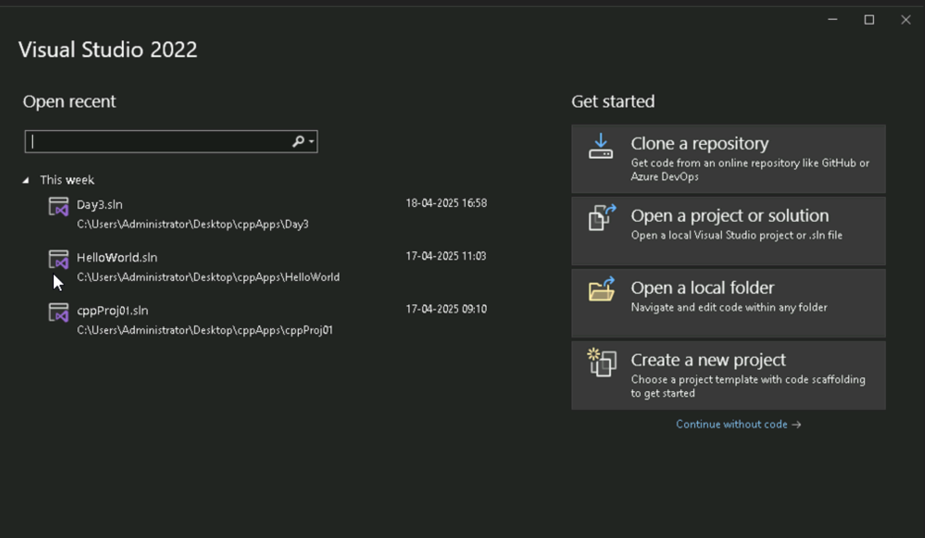

* Hear it shown (create a new project )option
* Click (create a new project) option,for creating a new project

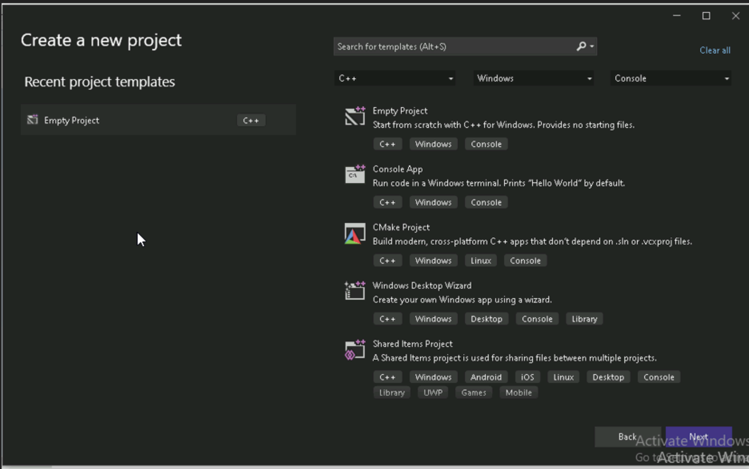

* After click (create new project)the above page will open
* Here we need to select three options there are:

1. Language(C++)
2. Plateform(windows)
3. Console

* After select all the options then select (console project) then click (Next) button in the bottom of the page

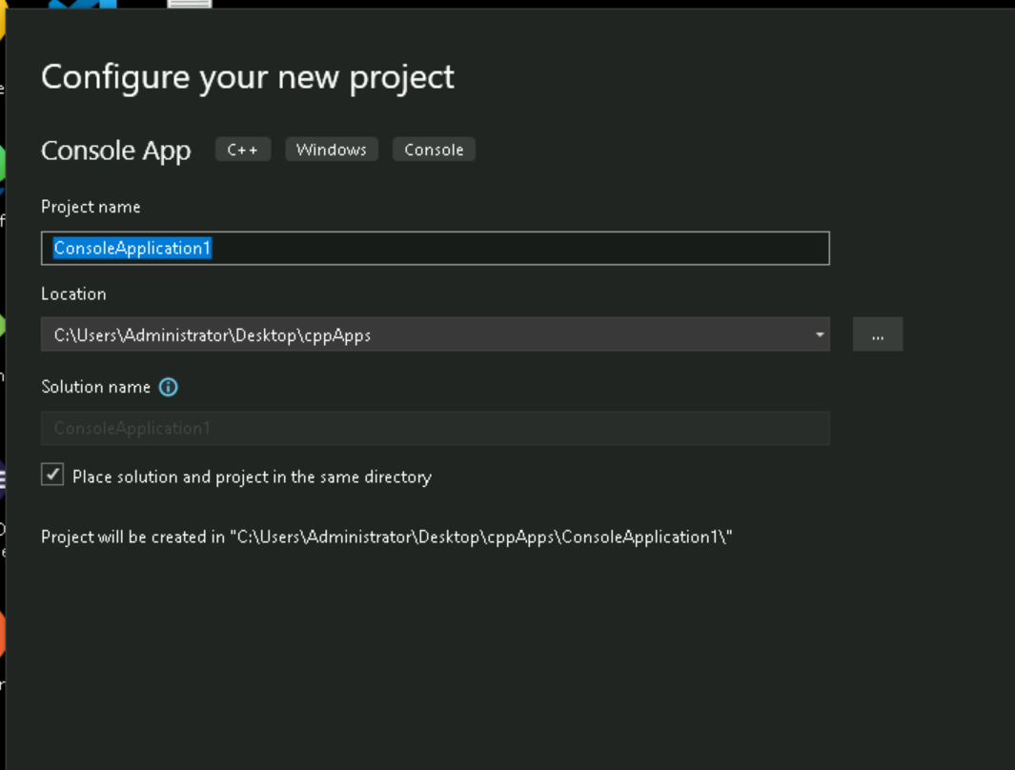

* The (configure your new project) page will open. It looks like the above image
* Here we create (project name),and then select(project location)and click the (check box)
* After done all those things then click (create)button

* The new project is created with project name as(ConsoleApplication1)

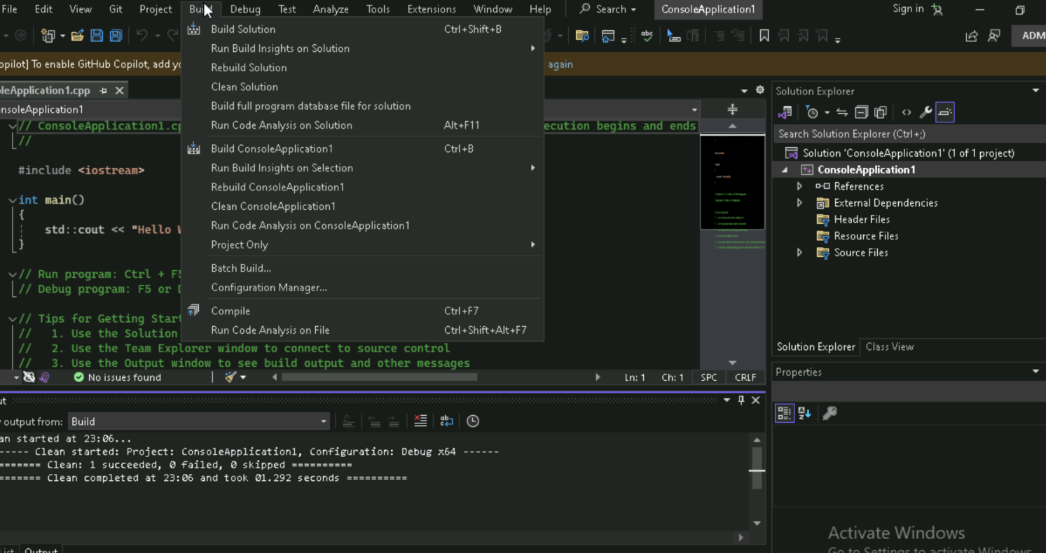

* In this page we have (build) option ,before run the program
* Click the (build) tag and click (clean ConsoleApplication1) again click (build solution) for compile the program
* After compilation click (arrow-run) for run program

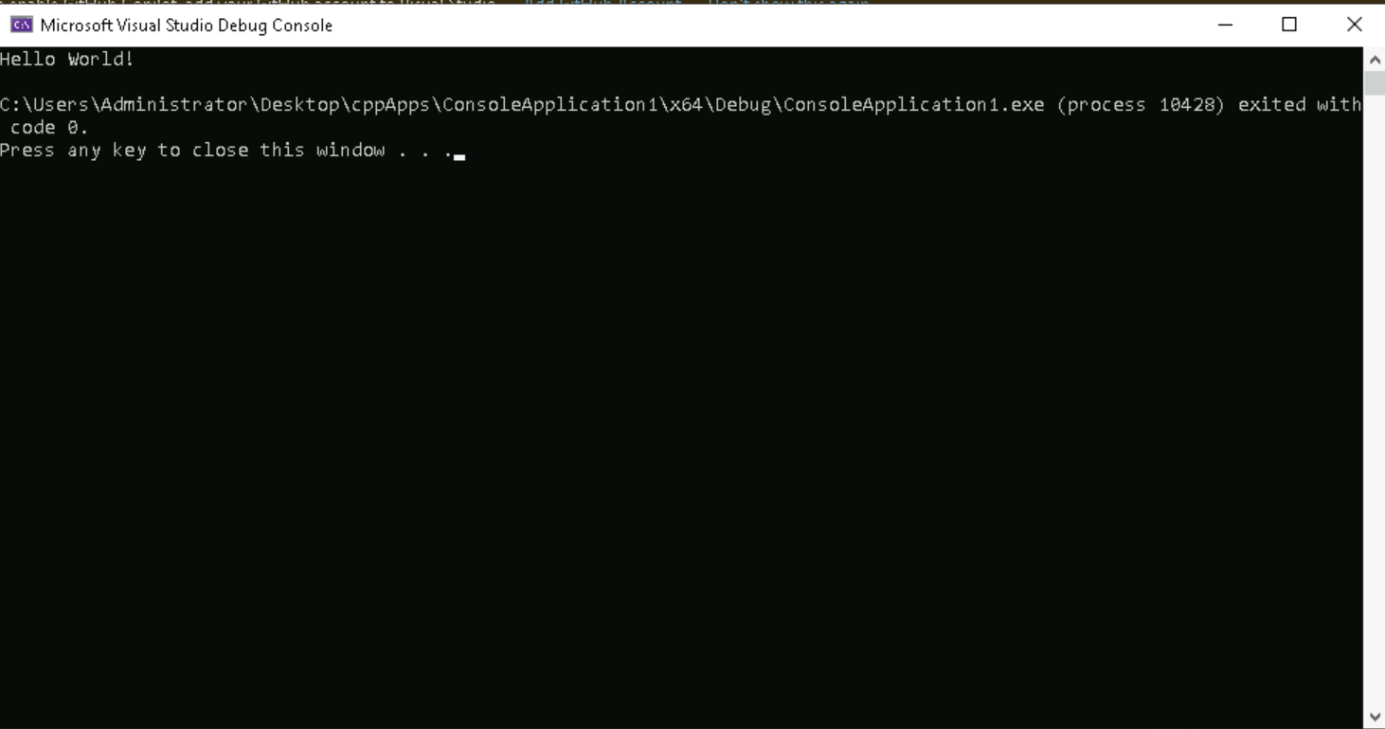

* It runs the program and give output “Hello World”

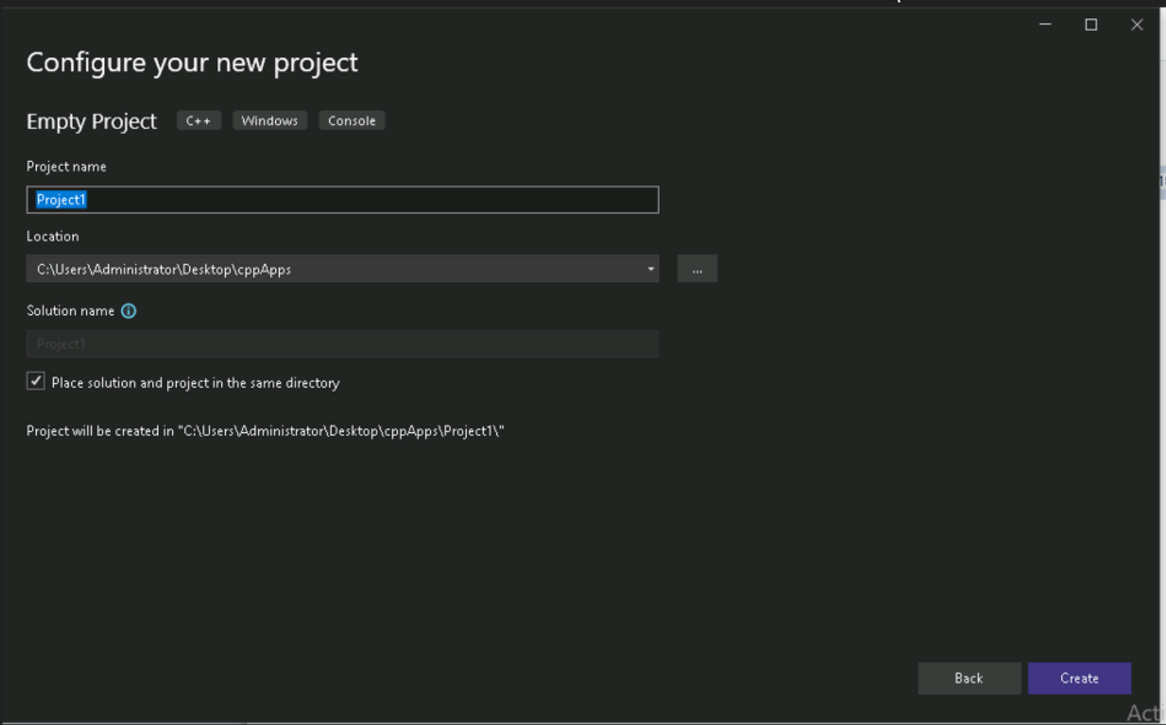

* We have another option for creating a project is (Empty project) then click (next) button in the bottom of the page
* New project created here we add (.cpp)file and write simple “Hello World” program
* Compile the program and run the program

* It runs the program and give output “Hello World”

Add different Folders inside the project as src, lib, bin and inc

             src – Store the Source file (.cpp)

             bin – Used to store the binary file or executable files(a.exe)

             inc – Used to store the header files(.h)

             lib – It is used to store object files, library files(.o , .s , .lib)

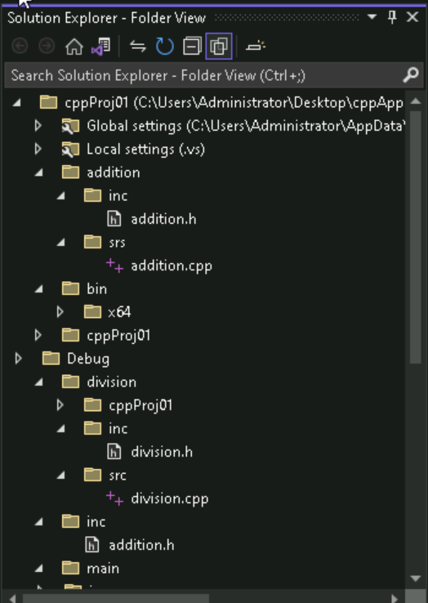

* Here we do one simple (Arithmetic operation)project,It includes
* Addition folder
* Inc-include
* addition.h
* Srs-source
* addition.cpp
* Substraction folder
* Inc-include
  + - substraction.h
* Srs-source
* substraction.cpp
* Multiplication folder
* Inc-include
* multiplication.h
* Srs-source
* runmultiplication.cpp
* Division folder
* Inc-include
* division.h
* Srs-source
* division.cpp
* The above structure we follow for doing Arithmetic operation project and run the program get output

* Here we use (bin) for-store the output file generate during the build process
* Click properties and go to configuration properties page
* General-click general, In (general properties) there is (output directory) click dropdown menu and select (Edit) and add (bin)
* Select (ok) and click(apply) button,The bin created

To ignore the warnings there are two ways:

1. Copy the Warning/error number then,

In Solution Explorer, right-click on the project node -> select Properties->C/C++->Advanced->Disable specific warnings->paste the copied error id ->Select Apply to make changes.

1. Copy the Warning(macro) then,

In Solution Explorer, right-click on the project node -> select Properties->C/C++->PreProcessor->PreProcessor Definitions->Paste the copied Warning(macro).